Art BINGO!
Choose an activity, create some art, see how many you can do.

Found object colour wheel.  Find objects around your house and arrange them into the colour wheel. Take a Photo. | Toilet Roll Canvas  Use those spare loo rolls to create as some art! Use a biro to draw a famous scene or whatever you like! | Data Drawing  Each symbol represents an action or emotion. A diary of your day or week. See page below for symbol glossary.
Found Faces.  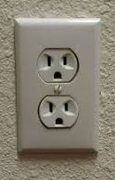  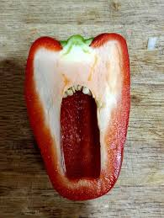  Can you see faces in everyday objects? Photograph them.  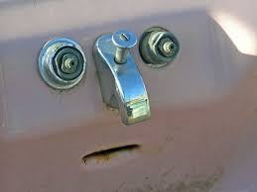 | Loo roll Cut outs.  Cut out miniature people or a scene of your choosing. Glue or slide into place inside a roll to create a tunnel scene.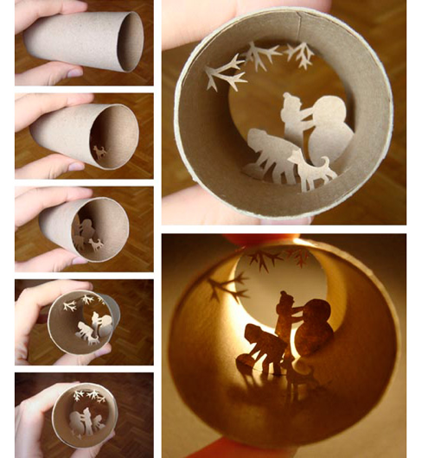 | Lined paper illusion.  By drawing on every other line this creates the illusion of your drawing being behind bars.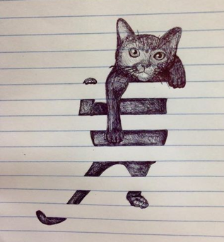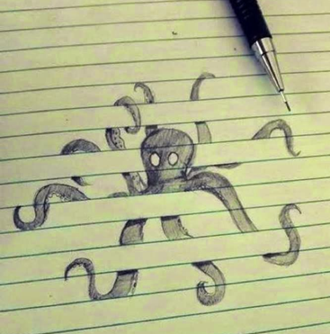
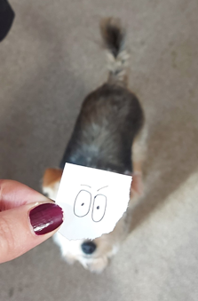  Give your family members new faces!  Draw a character or just some eyes and photograph them over family members or objects.  (one on the right is Miss Williams's attempt!) | Loo Roll Flowers  Squash and cut your loo rolls to make beautiful flower patterns.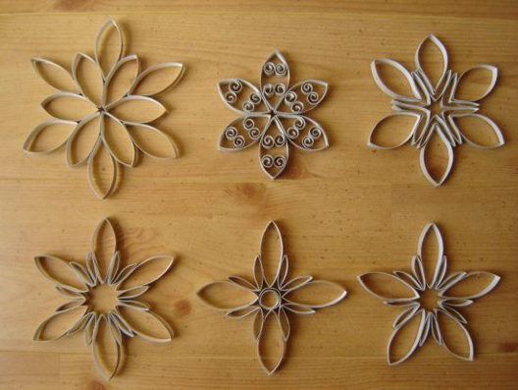 | Collage animals.  Use colour paper, magazines, Newpaper and cut up geometric shapes to create an animal. If you google ‘geometric animal outline’ and search for images it will bring up lots of templates you could copy or print out.
Drawing and everyday objects.  Draw around an everyday object to turn into something new. | Loo Roll Creatures.  What creature will you make?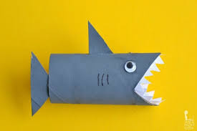 | Hand Illusion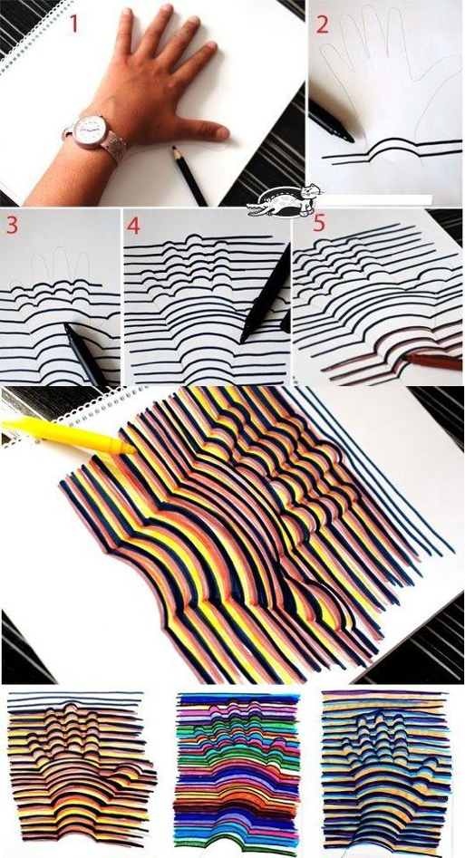

Data drawing Glossary
Use these data symbols to create an abstract drawing representing your week! You can arrange the symbols however you like on your page. You can also repeat symbols and you can vary the size of each symbol to give your image more depth.
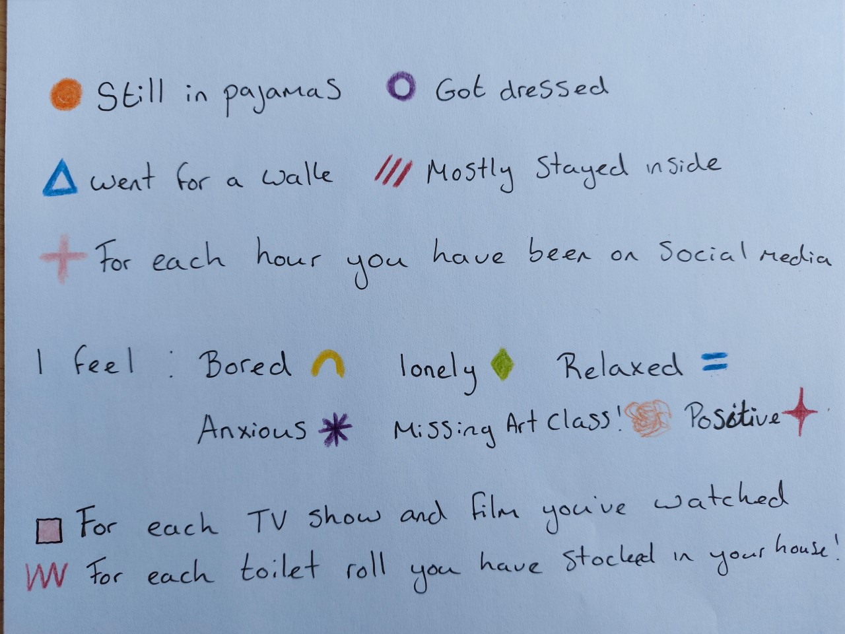

You could also add different symbols to represent a different action or emotion too.

