Creative Thinking – Thinkers Keys

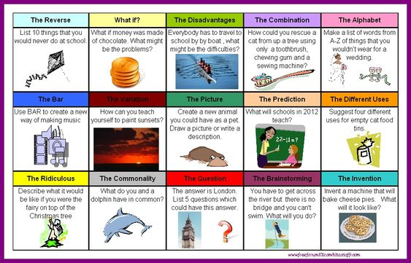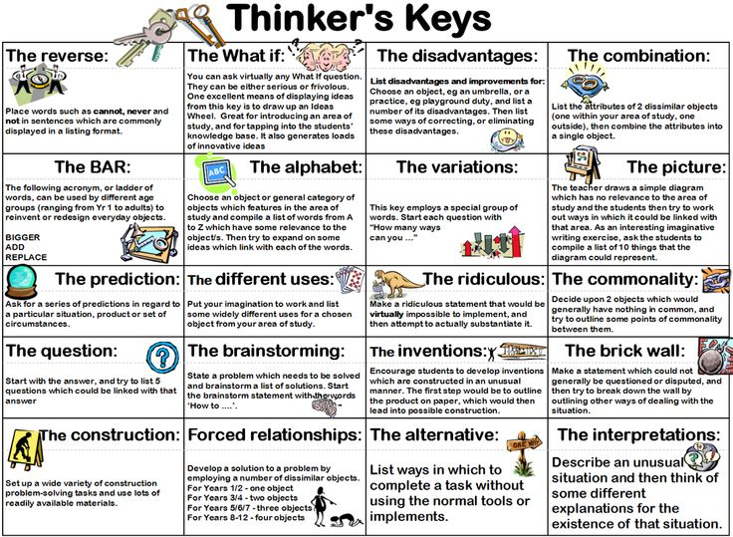

Thinkers keys are a range of question starters devised by Tony Ryan to help children think creatively. They can be applied to almost any subject.

